Step 1: Change Release Note file name

M2_C1_DC_VC1_BSW_04_Eaton_SW_Release_Note >> M2_C1_DC_VC1_BSW_05_Eaton_SW_Release_Note

Change everywhere - for example (BSW_04 to BSW_05)

Q-

How many types of release?

3 Types

formal – all doc give user ITP, ITR, application doc VNV doc, utr, utp, cpld stack -

test build – stack, release note, acceptance test log, MemMap ITR, ITP, user manual, test logs

hotfix – ITP, ITR, Test acceptance

Step 2: Header

Change release date, release name

# Step 3: Description

# Step 4: Delivered File

Q –

Which file will be delivered who decided?

Who will give Test Log/test report file? Vnv -Nandkishor/

Who will give testing result? Vnv

When will we give comment in comment section?

Step 5: Exception

# Step 6: Module change log

1. First copy last 4 column and paste in the last column for update latest change

|  |  |  |  |
| --- | --- | --- | --- |
| **Update site Version** | **SW Version** | **Maturity** | **Changes since M2_C1_DC_VC1_BSW_04_31_Jan_2022 software Release** |

Change since **M2_C1_DC_VC1_BSW_04_10_Jan_2022 to M2_C1_DC_VC1_BSW_05_31_Jan_2022**

Note: 31_jan_2022 is release date

1. Now change in **Description** B column

Replace all description with No Change

1. Now update all change in description according to Module wise
2. Q- What is Maturity when it will be change

Owner will give input...

# Limitations

# Validation Metrics

* Take input from VNV team for ITR test cases remains and corrected
* Change this table

|  |  |  |  |  |  |  |  |
| --- | --- | --- | --- | --- | --- | --- | --- |
| **Module Name** | **ITR Test Cases** | **ITR Test OK** | **ITR Test partially OK** | **ITR Test NOK** | **ITR Test NR (not realized)** | **Conformity Test Ok / (Tests realized)** | **Coverage Tests realized / Sum of tests** |

Fill this data from ITR file in Test result sheet

# Resource utilization Matric

1. CPU load & System load

**Take input from Acceptance test report**

Change – sw(VC1) min CPU1, max cpu1

Sw(VC1) Min CPU2 Max CPU2

1. Memories consumption

Change in **Flash Code consumption (Bytes)**

Take input from Memory Map

For Flash Code

|  |
| --- |
| Application Header |
| Application |

For flash Calib

|  |
| --- |
| Calibrations Header |
| Calibrations ROM |

1. Stack consumption

**Take input from VNV team**

For cpu2 and CPU 2

Change in Stack CPU1 consumption (Bytes)

1. RAM

Change in RAM consomption (Bytes)

Teke input from MenMap

|  |
| --- |
| CPU0_Stack |
| CPU1_Stack |
| cRAM0_Data |
| Calibrations CRAM |
| EIM_Free_RAM |
| iRAM_R_APP_PAT |
| iRAM_R_Session_Id |
| iRAM_R_ResetFlag |
| Retention RAM |
|  |

Add All 5 row and fill sum of 5 rows

1. NVRAM

Ask to Divya

Any update or new block added?

# How to create Review screen

1. Login <http://unipro.kpit.com/>
2. Select project name –
3. 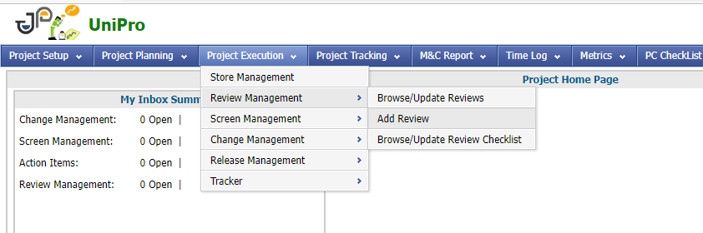
4. Graphical user interface, application

   Description automatically generated
5. Uniphase – Software (Always)
   1. Cycle – cycle created by Project Manager
   2. Reviewers – Ask to PM
   3. Planned completion Date – in most case current date
6. If u have required to give multiple docs, then u can use Attach file
   1. For stack give git link in txt file.
   2. For another file (MemMap, acceptance) u can give git link.
7. In checklist Name

Build Review Checklist (Always select)

1. Category

Whatever file you want to give for review (Integrated stack, ITP, ITR, User Manual)

Choose Yes

Which file has not for review then select N/A.?

Then submit screen review.

Thank you